>

**слабые и сильные разрывы решений нелинейных уравнений**

Оспанова Алия

> **restart:**

> **with(plots);**

ввод исходных данных

F(u)=cosu, u(x)=sinx

> **F:=u->cos(u);**

> **u0:=x->x;**

>

решение уравнения u-u0(x-F(u)*t)=0 при t=0

> **implicitplot(u-u0(x),x=-1..1,u=-1..1);**

решение уравнения u-u0(x-F(u)*t)=0 при t=0.5

> **implicitplot(u-u0(x+sin(u)*0.5)=0,x=-1..1,u=-1..1)**

>

> **A:=implicitplot((u-u0(x),x=-1..1,u=-1..1),style=line,color=blue):**

**G:=implicitplot((u-u0(x+sin(u)*0.5)=0,x=-1..1,u=-1..1),style=point):**

**display({A,G},axes=boxed,scaling=constrained,title=`Cosine and Tangent`);**

>

>

> **A:=implicitplot((u-u0(x),x=-1..1,u=-1..1),style=line,color=blue):**

**G:=implicitplot((u-u0(x+sin(u)*0.1)=0,x=-1..1,u=-1..1),style=line,color=green):**

**B:=implicitplot((u-u0(x+sin(u)*0.2)=0,x=-1..1,u=-1..1),style=line,color=violet):**

> **J:=implicitplot((u-u0(x+sin(u)*0.3)=0,x=-1..1,u=-1..1),style=line,color=yellow):**

> **K:=implicitplot((u-u0(x+sin(u)*0.4)=0,x=-1..1,u=-1..1),style=line,color=brown):**

> **T:=implicitplot((u-u0(x+sin(u)*0.5)=0,x=-1..1,u=-1..1),style=point,color=green):**

> **L:=implicitplot((u-u0(x+sin(u)*0.6)=0,x=-1..1,u=-1..1),style=point,color=violet):**

> **X:=implicitplot((u-u0(x+sin(u)*0.7)=0,x=-1..1,u=-1..1),style=point,color=orange):**

> **S:=implicitplot((u-u0(x+sin(u)*0.8)=0,x=-1..1,u=-1..1),style=point,color=yellow):**

> **P:=implicitplot((u-u0(x+sin(u)*0.9)=0,x=-1..1,u=-1..1),style=point,color=pink):**

> **F:=implicitplot((u-u0(x+sin(u)*1)=0,x=-1..1,u=-1..1),style=point):**

> **display({A,G,F,B,J,K,T,L,X,S,P},axes=boxed,scaling=constrained,title=`Cosine and Tangent`);**

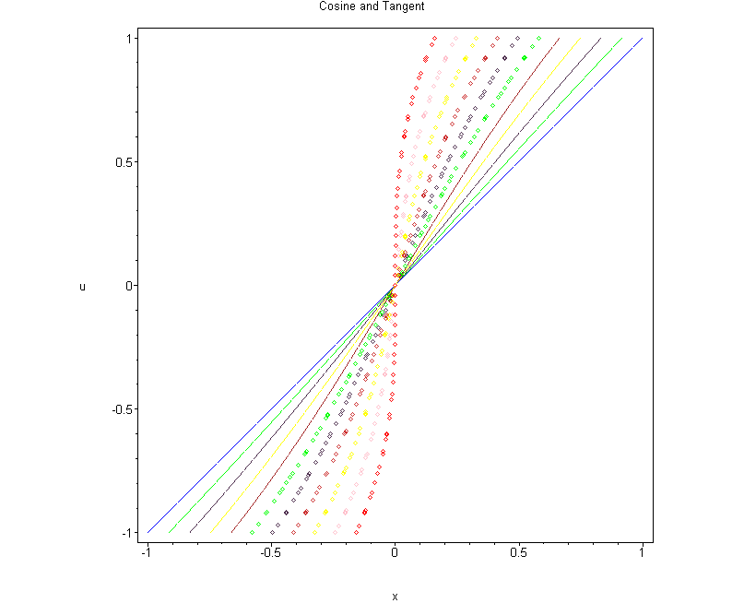

> **with(plots);**



> **animate([implicitplot(u-u0(x+sin(u)*t)=0,x,x=-1..1,u=-1..1)],t=0..1,frames=10,color=red,style=line);**

>

Error, (in implicitplot) two dimensional plots handled only for this function

>

>

>

>